**3. HALLUCINGOENS AND CANNABIS**

Other kinds of substances may also cause problems for their users and for society. Hallucinogens produce delusions, hallucinations, and other sensory changes. Cannabis produces sensory changes, but it also has depressant and stimulant effects, and so it is considered apart from hallucinogens in DSM-5. And many people take combinations of substances.

Hallucinogens are substances that cause powerful changes in sensory perception, from strengthening a person’s normal perceptions to inducing illusions and hallucinations. They produce sensations so out of the ordinary that they are sometimes called “trips.” The trips may be exciting or frightening, depending on how a person’s mind interacts with the drugs. Also called *psychedelic drugs,* the hallucinogens include LSD, mescaline, psilocybin, and MDMA (Ecstasy) (Many of these substances come from plants or animals; others are produced in laboratories

1. **LSD (lysergic acid diethylamide)**

**O**ne of the most famous and most powerful hallucinogens, was derived by Swiss chemist Albert Hoffman in 1938 from a group of naturally occurring drugs called *ergot alkaloids.* During the 1960s, a decade of social rebellion and experimentation, millions of people turned to the drug as a way of expanding their experience. Within 2 hours of being swallowed, LSD brings on a state of *hallucinogen intoxication,* sometimes called *hallucinosis,* marked by a general strengthening of perceptions, particularly visual perceptions, along with psychological changes and physical symptoms. **People may focus on small details—the pores of the skin, for example, or individual blades of grass. Colors may seem enhanced or take on a shade of purple. People may have illusions in which objects seem distorted and appear to move, breathe, or change shape. A person under the influence of LSD may also hallucinate—seeing people, objects, or forms that are not actually present**.

Hallucinosis may also cause one to hear sounds more clearly, feel tingling or numbness in the limbs, or confuse the sensations of hot and cold. Some people have been badly burned after touching flames that felt cool to them under the influence of LSD. The drug may also cause different senses to cross, an effect called *synesthesia.* Colors, for example, may be “heard” or “felt.”

**LSD can also induce strong emotions, from joy to anxiety or depression. The perception of time may slow dramatically. Long-forgotten thoughts and feelings may resurface. Physical symptoms can include sweating, palpitations, blurred vision, tremors, and poor coordination. All of these effects take place while the user is fully awake and alert, and they wear off in about 6 hours.**

The drug poses dangers for both one-time and long- term users. It is so powerful that any dose, no matter how small, is likely to produce enormous perceptual, emotional, and behavioral reactions. Sometimes the reactions are extremely unpleasant—a so-called bad trip (when LSD users injure themselves or others, for instance, usually they are in the midst of a bad trip).

Long term effects: some users eventually develop psychosis or a mood or anxiety disorder. And a number have *flashbacks*—a recurrence of the sensory and emotional changes after the LSD has left the body. Flashbacks may occur days or even months after the last LSD experience.

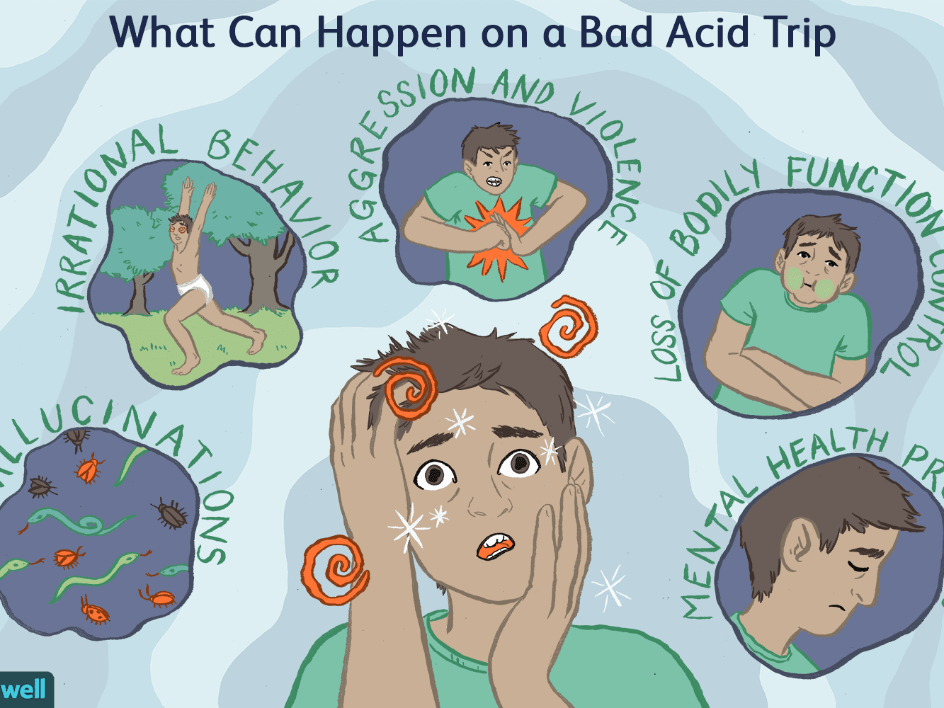



1. **Cannabis**

*Cannabis sativa,* the hemp plant, grows in warm climates throughout the world (also known as marijuana among other names) the drugs produced from varieties of hemp are, as a group, called **cannabis.** The most powerful of them is *hashish;* the weaker ones include the best-known form of cannabis, **marijuana,** a mixture derived from the buds, crushed leaves, and flowering tops of hemp plants. More than 19 million people over the age of 11 (7.3 percent of the population) currently smoke marijuana at least monthly; more than 5 million smoke it daily (NSDUH, 2013)

Of the several hundred active chemicals in cannabis, **tetrahydrocannabinol (THC)** appears to be the one most responsible for its effects. The higher the THC content, the more powerful the cannabis; hashish contains a large portion, while marijuana’s is small. When smoked, cannabis produces a mixture of hallucinogenic, depressant, and stimulant effects. At low doses, the smoker typically has feelings of joy and relaxation and may become either quiet or talkative. Some smokers, however, become anxious, suspicious, or irritated, especially if they have been in a bad mood or are smoking in an upsetting environment. Many smokers report sharpened perceptions and fascination with the intensified sounds and sights around them. Time seems to slow down, and distances and sizes seem greater than they actually are. This overall “high” is technically called *cannabis intoxication.* Physical changes include reddening of the eyes, fast heartbeat, increases in blood pressure and appetite, dryness in the mouth, and dizziness. Some people become drowsy and may fall asleep.

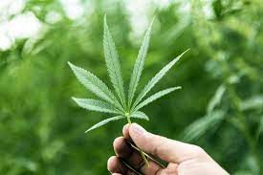In high doses, cannabis produces odd visual experiences, changes in body image, and hallucinations. Smokers may become confused or impulsive. Some worry that other people are trying to hurt them. Most of the effects of cannabis last 2 to 6 hours. The changes in mood, how- ever, may continue longer.

**Cannabis Use Disorder** Until the early 1970s, the use of marijuana, the weak form of cannabis, rarely led to a pattern of *cannabis use disorder.* Today, however, many people, including large numbers of high school students, are developing the disorder, getting high on marijuana regularly and finding their social and occupational or academic lives very much affected.

Many regular users also develop a tolerance for marijuana and may **feel restless and irritable and have flulike symptoms when they stop smoking** (Chen et al., 2005)

**Is Marijuana Dangerous?** As the strength and use of marijuana have in- creased, researchers have discovered that smoking it may pose certain dangers (Price, 2011). It occasionally causes panic reactions similar to the ones caused by hallucinogen- gens, and some smokers may fear they are losing their minds (APA, 2000). Typically such reactions end in 2 to 6 hours, along with marijuana’s other effects.

Because marijuana can interfere with the performance of complex sensorimotor- tor tasks and with cognitive functioning, it has caused many automobile accidents (Brady & Li, 2014). Furthermore, people on a marijuana high often fail to remember information, especially anything that has been recently learned, no matter how hard they try to concentrate; thus heavy marijuana smokers are at a serious disadvantage at school or work (Budney et al., 2011; Jaffe & Klein, 2010).

One study compared blood flow in the brain arteries of chronic marijuana users and nonusers (Herning et al., 2005). After one month of abstinence from smoking marijuana, chronic users continued to have higher blood flow than nonusers. Though still higher than normal, the blood flow of light marijuana users (fewer than 16 smokes per week) and of moderate users (fewer than 70 smokes per week) did improve somewhat over the course of the abstinence month. The blood flow of heavy users, however, showed no improvement. This lingering effect may help explain the memory and thinking problems of chronic heavy users of marijuana.

© Anthony Bolante/Reuters/Corbis

There are research indications that regular marijuana smoking may also lead to long-term health problems (Budney et al., 2011; Whitten, 2010). It may, for example, contribute to lung disease, although there is considerable debate on this issue (Pletcher et al., 2012; NIDA, 2002, Tashkin, 2001). Some studies suggest that marijuana smoking reduces the ability to expel air from the lungs, perhaps even more than tobacco smoking does. Another concern is the effect of regular marijuana smoking on human reproduction. Studies since the late 1970s have discov- ered lower sperm counts in men who are chronic smokers and abnormal ovulation in women who are chronic smokers.